No. | Answer
n(Ba(NO₃)₂) = c × V = 0.450 × 0.2000 = 0.0900 mol = n(Ba²⁺)
n(BaSO₄) = n(Ba²⁺) = 0.0900 mol
n(H₂O₂) = c × V = 4.30 × 3.50 = 15.05 mol
n(gaseous product) = × n(H₂O₂) = × 15.05 = 37.62 mol
V(gases) = n(gases) × 22.41 = 37.62 × 22.41 = 843 L
n(SO₂) = 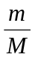 = 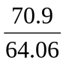 = 1.107 mol
n(OH–) = 2 × n(SO₂) = 2.214 mol = n(NaOH)
∴ V(NaOH) = = 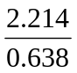 = 3.47 L
n(HNO₃) = c × V = 14.0 × 0.125 = 1.75 mol
n(Hg) = × n(HNO₃) = 0.6562 mol
∴ m(Hg) = n × M = 0.6562 × 200.6 = 132 g
n(Hg(NO₃)₂) = c × V = 0.144 × 0.0336 = 4.838 × 10^{–3} mol = n(Hg²⁺)
n(Br–) = × n(Hg²⁺) = 9.677 × 10^{–3} mol = n(NH₄Br)
∴ V(NH₄Br) = = 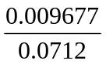 = 0.136 L
n(HCl) = c × V = 0.500 × 0.01885 = 0.009425 mol = n(H⁺)
n(Na₂CO₃) =  × n(H⁺) = 0.004712 mol
m(Na₂CO₃) = n × M = 0.004712 × 105.99 = 0.4994 g
% purity of Na₂CO₃ sample = 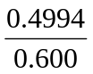 × 100 = 83.2%
m(CH₃COOH in vinegar sample) = 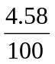 × 14.72 = 0.6742 g
n(CH₃COOH) = = 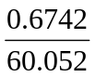 = 0.01123 mol
n(NaOH) = c × V = 0.307 × 0.02500 = 0.007675 mol = n(OH–)
Reacting ratio of CH₃COOH : OH– = 1:1, ∴ OH– is the limiting reagent
n(CH₃COO– formed) = n(OH– reacted) = 0.007675
c(CH₃COO–) = 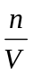 = 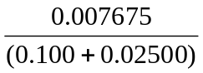 = 0.0614 mol L^{–1}

